**Number methods in JavaScript**

As everything in JS is an object with properties and methods, number also consider an object with methods but it doesn’t have properties.

These methods are:

**Identifier.toString(radix);**

This method is used:

1. To convert number value to string value.
2. Convert the current number to binary, decimal, hexadecimal systems by determine “**radix**” value. Radix is an optional value.

**Example:**

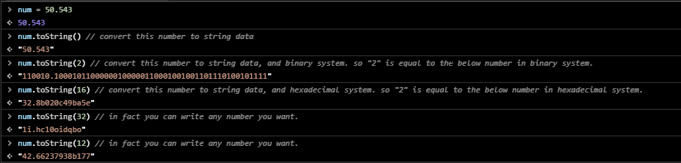

**Identifier.toExponential(fraction digits);**

This method is used to convert number from “integer” or “floating” state to “scientific | exponential notation” state. And return the new number as a string data, that’s happen because the presence of e in the scientific number (we need to preserve e character)

In case of floating numbers you can control number of digits after the floating point by specify “**fraction digits**”. Fraction digits is an optional value.

**Example:**

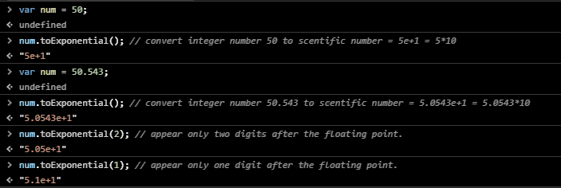

**Identifier.toFixed(fraction digits);**

This method is used to:

* + - Convert number to string.
    - Rounding it to a specified number of decimals “**fraction digits”.** Default n is **0,** fraction digits is an optional value.

**Note:** if the desired numbers of decimals are higher than the actual number, zeros are added to create the desired decimal length.

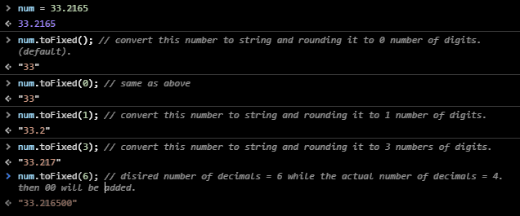

**identifier.toPrecision(precision);**

This method is used to:

1. Convert number data to a string.
2. Determine how many numbers you want to appear “**precision**”. Precision is an optional value.

**Note:** precision indicates to whole number, so the default value is the whole number.

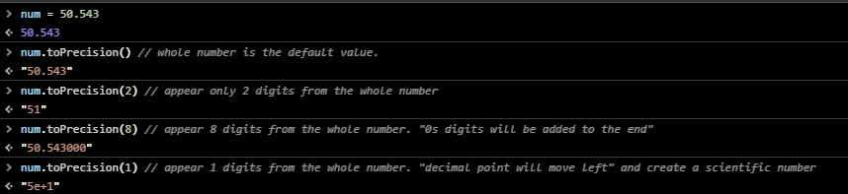

**Now you can make the differ between fixed and precision methods where the first appear digits after decimal point, whereas the second appear digits from the whole number.**

**IsNaN(n);**

This method is used to check if **n** is a number or not, where if n is a **number**, **Booleans**, or **“number**” return false else return true.

**Example:**

